To: Dr. David Trevas

From: Team Malawi

Date: 2/26/2021

Subject: Implementation Memo



# Summary

In the southeastern region of Africa, Malawi is a small landlocked country. It is also considered to be one of the poorest countries in the world, located in the south-eastern part of Africa. In order to make better use of organic materials found in Malawi, locals have set up composting sites where residents can dispose of compostable materials. In order to facilitate the transport of this compostable material, Team Malawi has been tasked with designing and developing a tricycle capable of transporting compost from tightly-packed neighborhoods to composting sites.

In Spring 2020, Team Malawi was awarded as a ME 386W project with this project. The team has agreed in Fall 2020 to continue this project and to create a device to support Malawi's people. Our team began this project by talking to Dr. McDonnell, our client, and knowing what her needs and the needs of the people of Malawi are. The team by now, Spring 2021, is able to come up with constraints and specifications for the design after consulting with the client. Team Malawi produced design alternatives after weighing the customer needs and engineering requirements and rated each with the criteria given.

This process resulted in a final design that met all the requirements of engineering and customer requirements. Two batteries are installed in the car and a DC engine with sufficient power and capacity. In a three-dimensional view, the team also produced a CAD model. The cost by now is still umber is well below the budget, so the team can make additional purchases during the testing and error phase if necessary. All parts needed and decided upon have been ordered and purchased as the time of writing this memo. In order to hopefully achieve a viable vehicle to support the people of Malawi, the following two months until the end of the Spring 2021 semester will consist of constructing and testing our final unit.

# Customer Requirements (CRs)

Professor McDonnell and Trevas were met by the team and they gave us a list of criteria they would like to see in the project. The customer requirements have been given to the team since last semester, Fall 2020, and have been fully maintained by the team during the building and testing process. Also, all requirements have been accounted for while ordering the parts needed for the device. The requirements have been given as follows:

* Maneuverable Size
* Safe to operate
* Durable design
* Operable off-roading
* Easy to Operate
* Maintainable
* Manufacturable
* Cost-efficient
* Reliable
* large Capacity
* Rechargeable
* Environment Friendly

According to the instructor and client, all of the items in the above list are items that the project needs to have. The team since last semester has taken into account every single requirement and has chosen the parts needed accordingly. All the parts that have been purchased under the requirements where they are must be maintainable, due to the very limited resources, Malawi can not continually buy new parts. Since the ultimate aim is to be able to make multiple machines for this country, it must be profitable. All are needed to be robust, lightweight, and operable on muddy roads because there are basically no paved roads and this design would be in constant use. For the same reason, it must also be effective and it needs to be safe and easy to operate, as it will be used by ordinary people. Finally, as stated by the instructor, it needs to be under the $1,500 budget.

# Engineering Requirements (ERs)

The group agreed to come up with a list of engineering specifications and requirements while planning and also during the building and testing phase, after hearing what the client needed for this project. The engineering requirements are things that can be measured and items that can be discussed quantitatively. The engineering requirements are listed as follows:

|  |  |  |
| --- | --- | --- |
| * Compact Size with lightweight | * High Capacity Battery | * Cost-Efficient |

## ER #1: Compact Size

### ER #1: 3x4ft Bed-Target = 12 sq. ft. with 6in. high walls.

This target was created because it is important to the client that this cart can fit well on the roads of Malawi which are known to be narrow. Because of this, the requirement was made to make sure that the cart didn’t exceed a certain width. However, the client wanted to be able to still maximize the amount that can be carried, therefore the length was elongated slightly and the height of the walls was made taller as well.

### ER #1: 3x4ft Bed-Target Tolerance = +/- 2 in.

The tolerance on this project is going to be very small due to the importance of this size. A 3x4ft be is an optimal size to have a decent area but still have a narrow width. The size of the wall is where this tolerance may impact the project the most. A 6-inch wall is a decent middle ground, but it may be possible to achieve an 8-inch high wall. This will not affect the height dramatically and will even add some volume to the amount that can be transported in one trip.

## ER #2: High Capacity Battery

### ER #2: Capacity of at least 10 Amp-hours- Target = 10 Ah

The motor that was purchased has a maximum voltage of 48 volts. With this, it is rated at 20.8 Amps which puts out a power of just under 1,000 Watts. This will give us about 600 rpm for the shaft rotation from the motor. And as long as the calculations are correct, the gearing that was chosen should allow for a proper speed. A higher-capacity battery is wanted because it is going to take quite a bit to keep the motor running for an extended period of time.

### ER #2: Capacity of at least 10 Amp-hours - Tolerance = +/- 2Ah

The group decided that 8Ah would be an acceptable capacity as this rating is accounting for a constant draw and the device will not be used constantly. This is, however, the baseline so the aim is to get a slightly higher capacity to maximize the capabilities. It is better to go for more capacity because it will account for any long days where the device may be used more or any other possible variables such as parasitic draw. This tolerance will allow the project to accept higher capacities without going below the minimum requirement that was set by the group.

## ER #3 (changed from fall): Cost under $1,500

### ER #3: Cost under $1,500 - Target = $1,250

The team's budget is $1500. The team believes that, according to the current bill of material, the current total budget should not exceed $1250, and $250 should be reserved for expenses incurred in response to some emergencies. Table 1 shows all the current materials that the team is going to use to build the prototype.

Table 1: Current Bill of Materials for the Project.

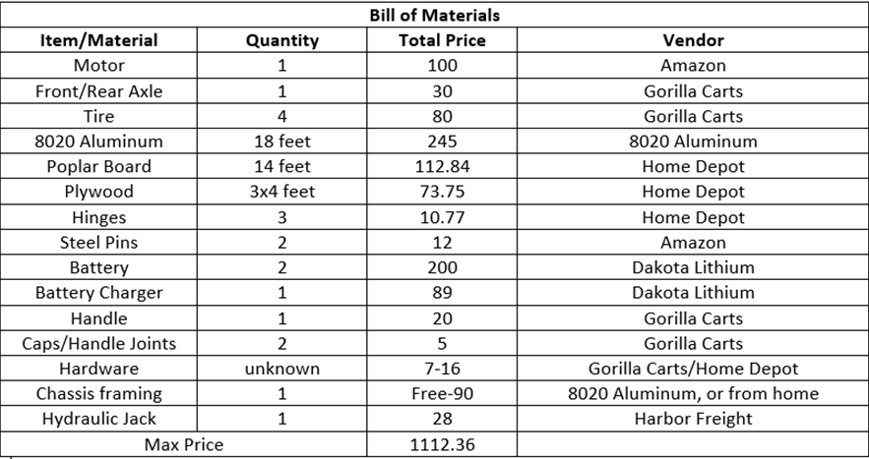

### ER #3: Cost under $1,500 - Tolerance = +/- $387

The maximum cost for this project is now set at $1,500, but the team is set to design towards only using $1112.36 to allow a contingency of $387.64. Besides, customers can provide tools for the team at the time of assembly, which will reduce the cost of purchasing tools for the team. The panel believes that the final cost will not exceed $1250, which satisfies the cost-efficient engineering requirement. This relatively low-cost and efficient vehicle will help people in Malawi better transport the composts.

# Design Changes

Since the beginning of the semester, a lot has changed for the final portion of the project. The largest part that has changed is the materials being used. The client decided that a prototype would be best and because of this, it would be okay to use wood as the material for the building of the bucket. The main reasoning behind this is because the original intent was to be able to take this to Malawi, but the client found it to be more difficult to do so than expected. The change was made to make it easier to build in the United States and keep it in the United States until further advancements are made in the transportation of the device. Using wood will also make it easier to construct and deconstruct which could help when the transportation is figured out. The dumping mechanism was also slightly changed. The removable door when dumping will no longer have dovetails that fit into the stationary walls, but rather will have removable pins that will keep the door in place when needed. This change was made to make it easier to machine the parts. It is quite difficult to machine a perfect-fitting dovetail of that length, and the dovetail can easily be broken if handled incorrectly. The pins will be much easier to remove and replace when needed.

## 3.1 Design Iteration 1: Change in dumping mechanism discussion

The team was going to use the hydraulic rods as the dumping mechanism at first. The workers will be allowed to remotely control the motor to expand and extend the hydraulic rod to realize dumping. However, through communication with customers, if the team uses a hydraulic rod, the manufacturing cost and maintenance cost will increase, and the team finally decided to use the 4-ton hydraulic jack. In this semester, the 4-ton hydraulic jack is sold out, so the team decides to use an 8-ton hydraulic jack instead. The manufacturing costs are slightly higher than before, but the 8-ton hydraulic jack will allow the team to transport and dump more composts. Besides, the team will place the hydraulic jack on the basket underneath the cart. Since the handle of the hydraulic jack is too short to reach, the team will attach several PVC tubes to lengthen the handle.

# Future Work

As of now, the current design is what the group intends to be the final. No other problems have arisen since the construction of the project. We have kept our client updated on any changes we have made as well and will continue to do so with any other future changes. Due to COVID, a lot of the supplies are taking longer than expected to get delivered for our project. Because of this, the group is currently waiting on the delivery of supplies to continue the construction of the project, and the adjusted schedule seems to fit accordingly.

## Further Design

The future manufacturing of this design includes the construction of the frame using the 8020 Aluminum. Once the frame is constructed, every piece will be able to be put together. As of now, the group has multiple components that are separate and the frame will bring them all together. The group is also still waiting on the steering components which will also need to be assembled with the frame. Once this is completed, testing will begin on the prototype.

## Schedule Breakdown

Below is an updated team Gantt chart. COVID has affected the delivery dates of many items needed to start the building process, but the team still believes they are on track to finish the project in a timely manner.

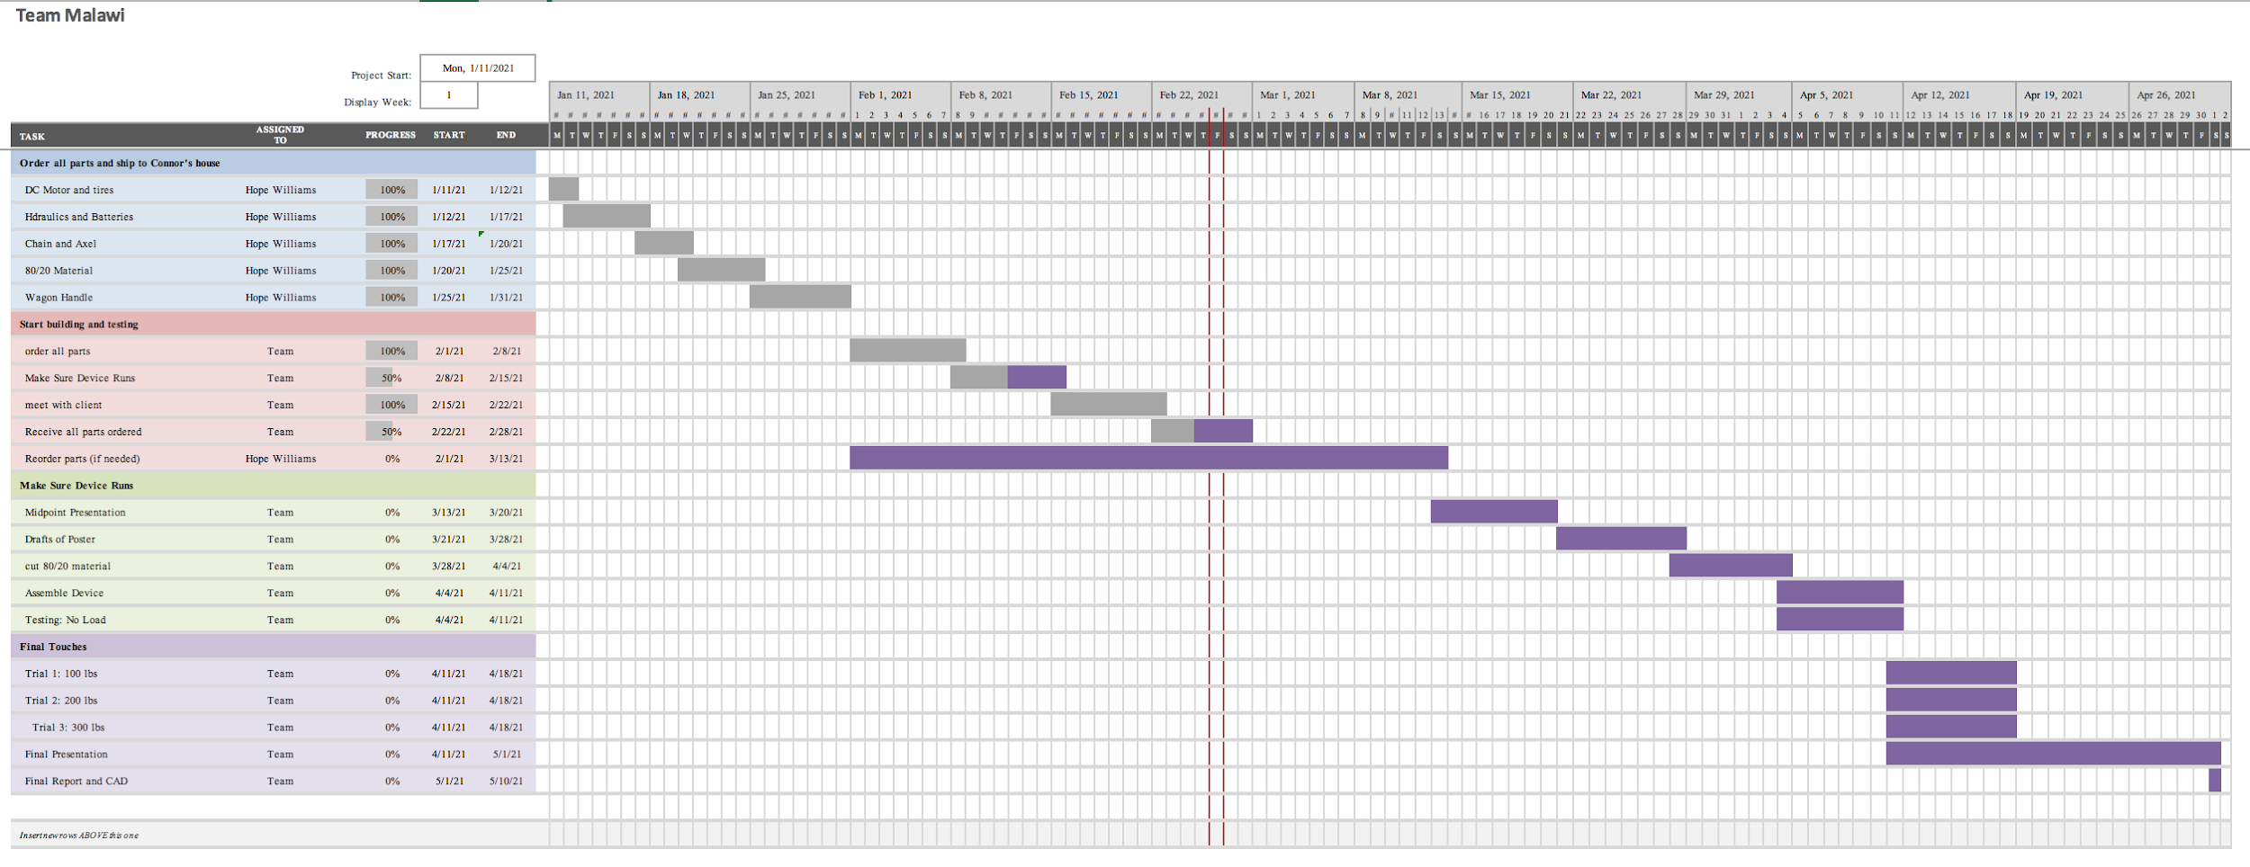

Figure 1: Updated Team Gantt Chart